High Power 9 Pin Connector

(Stage Connector)

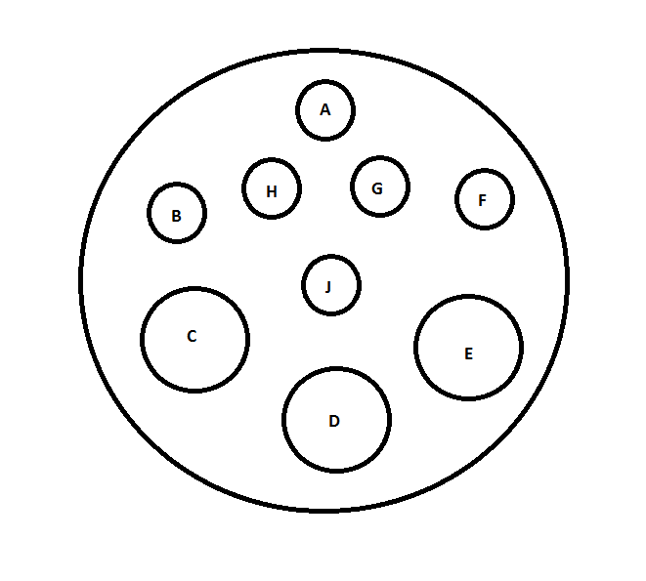

|  |  |  |
| --- | --- | --- |
| Pin # | Description | Wire Color |
| Pin A | RTD+ (red) | Red |
| Pin B | RTD- (white) | Black |
| Pin C | TE+ | Red |
| Pin D | Ground | Green |
| Pin E | TE- | Black |
| Pin F | Bimetallic | Purple |
| Pin G | Bimetallic | Purple |
| Pin H | RTD- (white) | Black |
| Pin J | Open |  |